Spartan Dairy 3: A guided tour for getting started

This document includes:

- Launching the Program
- Application Window
- Spartan Dairy Data Files
- Feed Library Window
- Ration Window
- Using the Worksheet
- Measurement Systems
- User Input Controls
- Sample Files
- Keyboard Shortcuts

Launching the Program

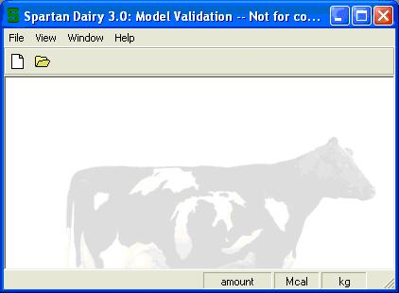
Start Spartan Dairy 3 like any other Windows program—just look for the green Spartan S.

Application Window
Main Menu
Once you open the program, you will first see the main application window. The main menu has only four choices: File, View, Window, and Help.

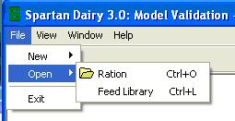

Arranging Child Windows
A child window is any window that can be opened from the main application. You can move these windows and resize them as with any MS Windows program.

Application Toolbar
The application toolbar 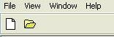 has two options. These can be used to create or open a ration file.
Status Bar
The status bar is at bottom of the Spartan window – if you move the mouse over a button, clickable object, or other field, the status bar provides information related to the mouse location. The status bar also tells you what the program is doing at the moment and what basis the program is currently working. In the screenshot below, the mouse was over the “kg” status button. Note the status bar tells you what it does.
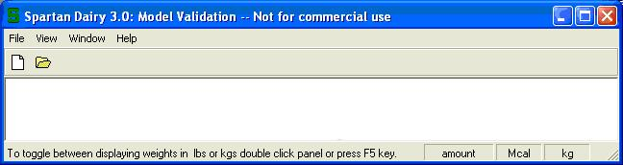

Spartan Dairy Data Files
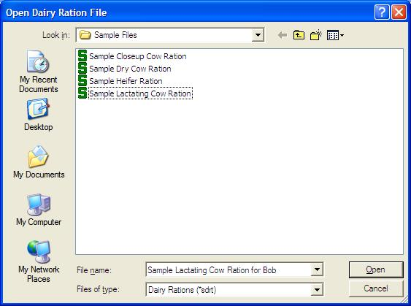
There are two types of Spartan data files: feed libraries and rations. To open an existing ration file, choose the File > Open > Ration command, use the Open Ration button, or type Ctrl+O. This will take you to a browsing window, similar to that of most Windows programs. The look of this dialog will depend on which Windows platform you are using.

In Windows XP, it looks like this. To move to a higher folder, you click the yellow up arrow icon to the right of the box that says “Sample Files”.

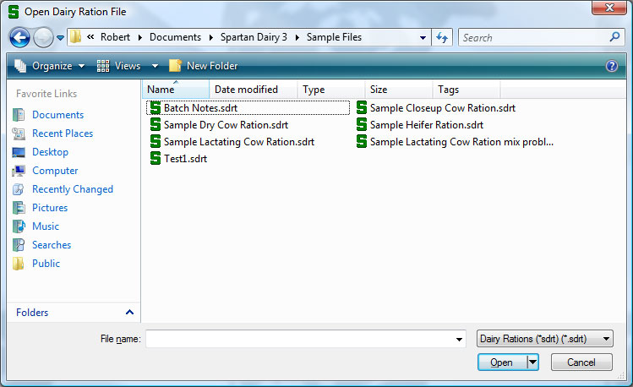

In Windows Vista or Windows 7, it looks like this.

To move to a higher folder, you click the name of the folder in the hierarchy. For example, click on “Spartan Dairy 3” to go up one level.

By default, the first time you launch Spartan Dairy 3, it will open the folder where the master feed library is. Within that folder, you will find a "Sample Files" folder than contains the sample feed library and sample rations. The full path to this folder is different under different operating systems, and by default, it will be in a "Spartan Dairy 3" folder within the /All Users/My Documents/ folder hierarchy. However, you have the ability to change the location of these files during program installation. In any case, do not be alarmed if you don’t see Spartan dairy files in the Open Dairy Ration or Library window—you may have to browse to find the correct folder where your data files are located.
Saving Files: Files can be saved by the File > Save or File > Save As command, the File toolbar button, or typing Ctrl+S.

Closing Files: To close a file, choose File > Close or hit the button.

Where are Files Stored? Files can be stored in any drive, directory, or folder. Using a folder within My Documents is recommended.
Feed Library Window
The window for a feed library contains a list of feeds along with nutrient characteristics organized into 12 tabs. The home tab gives general for each feed and contains %DM along with duplicate information from some of the other tabs. All feed characteristics that are values (not calculations) can be edited. Calculated values are shown in a library using standard assumptions for a high producing cow so that the implications of edited feed values can be seen immediately. For example, if you edit the B protein fraction, you can see impact on %RUP and %RDP.

NOTE: You cannot edit any feeds in the Master Feed Library. Copying the Master Feed Library using Windows will not alter this protection. To make a new library, you can copy our Sample Feed Library in Windows, you can start with the Sample Library in Spartan and add to it, or you can start a new library from scratch.

An example of a feed library—the Master Feed Library.

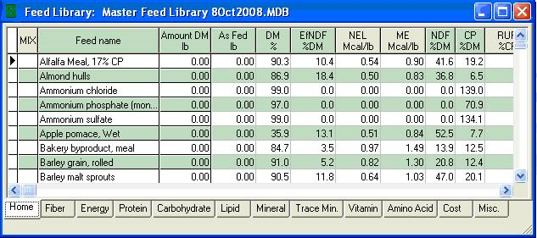

When working in a feed library, the Spartan library menu and toolbar appear at the top of the Spartan window. They contain the necessary commands for working with libraries, the most useful being to add new feeds, copy and paste feeds, update feeds, sort feeds, and save the revised library.
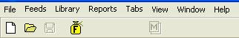

Ration Window
The window for a ration contains
- a summary of key animal descriptors
- a list of feeds with the amount of each and nutrient characteristics organized into 12 tab sheets.
- a summary of the ration supply and requirements for each nutrient
- a graph that quickly summarizes nutritional adequacy of a ration
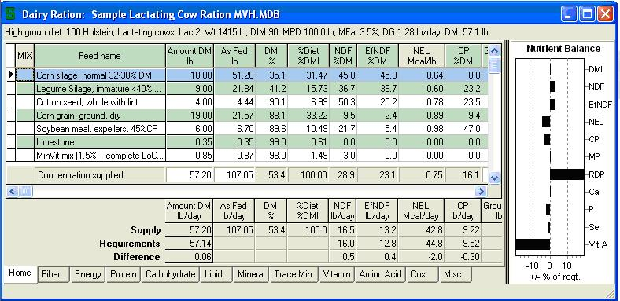
1
2
3
4

When working in a ration, the Spartan ration menu and ration toolbar appear at the top of the Spartan window. They contain the necessary commands for working with rations and are explained in chapter 9 Working with Rations.
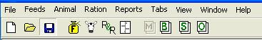

Using the Worksheet
Selecting a Tab Sheet
Tab sheets contain columns of feed characteristics. These 12 tabs appear at the bottom of the ration worksheet window. Simply click on the tab you want.
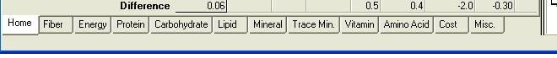
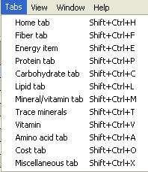
You can also select tabs using the ration menu item “Tabs” or use shortcut keyboard commands.

Measurement Systems
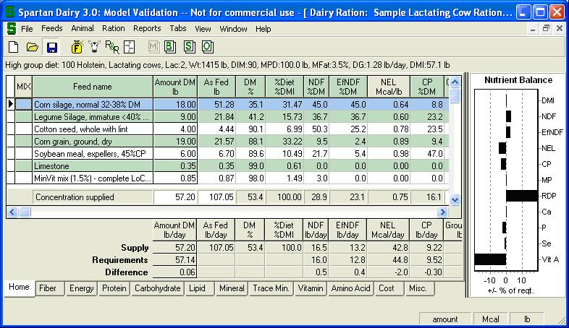
Three different measurement methods for evaluation feeds and rations can be used in Spartan Dairy 3. These can be quickly switched by using the boxes at the bottom right of the Spartan window. Occasionally you may notice these buttons disappear as you work with the program. Do not be alarmed. Usually just resizing the window will make them appear again.

Ration Summary Basis: The summary rows at the bottom of the ration worksheet can be viewed on a concentration or a total amount per day basis. Find the box in the lower right corner of the Spartan main window to see the current basis. indicates the program is currently in an amounts basis and indicates it is currently in concentration basis. If you want to switch to the other basis, just double click on this box. It acts as a toggle switch.

Energy Measures: The energy system of Spartan 3 can be examined in Megacalories (Mcal) or Megajoules (Mjoule). Find the box in the lower right corner of the Spartan main window to see the current energy system. It will be either or . If you want to switch to the other system, just double click on this box. It acts as a toggle switch.

Weight Measures: Spartan 3 can work in metric or in pounds. Even in pounds, however, minerals will be calculated in grams. To see the current basis, find the box in the lower right corner of the Spartan main window. indicates current weight is pounds and indicates metric. If you want to switch systems, double click this box.

User Input Controls – (Combo Boxes, Spin Edit Controls, Calendar Controls)
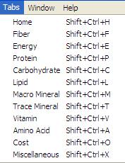
These work just like with any Windows program, and are pretty self-explanatory. Just try them and you will figure them out.

Sample Files
We have provided 4 Sample Rations and Sample Library with the program.

Keyboard Shortcuts
The keyboard shortcuts can be seen if you select the Tabs command from the worksheet menu.

